How to Upgrade TalentStudio

Pre-requisites

- Accurev client is installed and you have an accurev workspace
- Ant is installed and running
- Sqlplus is installed and running

Steps to upgrade your version of TalentStudio
Open accurev and move your workspace to the version you wish to upgrade to:

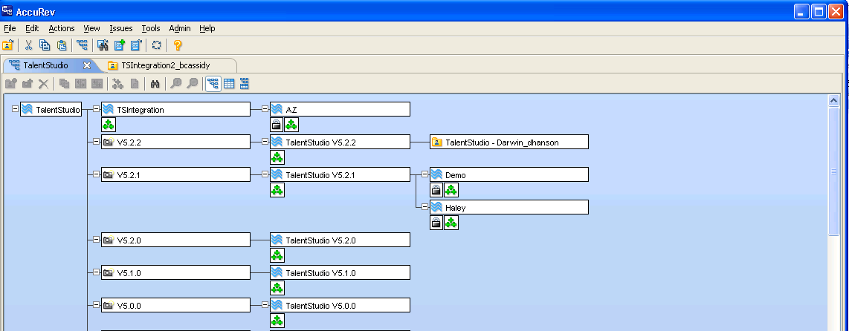
Workspace we will move for the demo

The picture below demonstrates the drag and drop required to move a workspace, this does not always work on the first attempt, so keep trying. Note we would not usually downgrade! The images are purely showing the movement of a workspace.
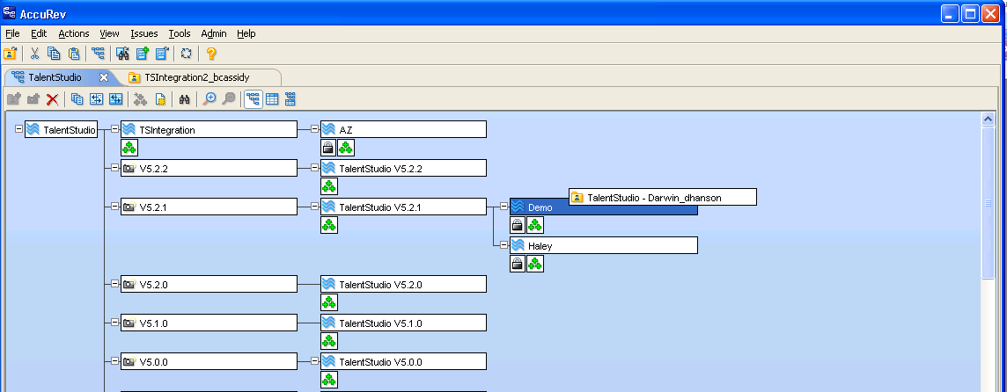
Here we are dragging our workspace onto the demo version off main version 5.2.1

Once we have moved our workspace we double click on it to open the following view

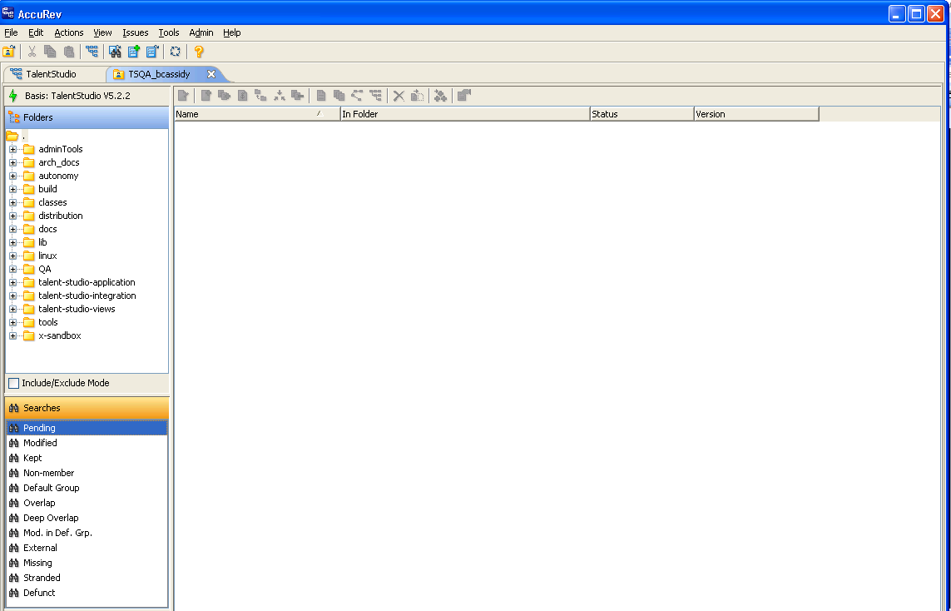
Hit this button to get the required codebase for the selected version

We are now finished with accurev.

Next step is to open a command prompt and CD to your project directory root as displayed

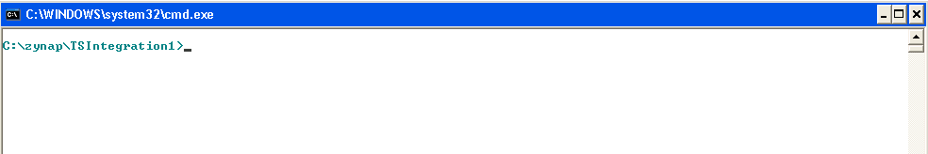

Now we build the project:

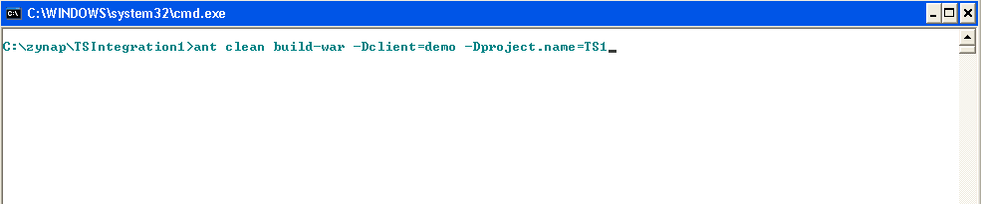

This command will place a TS1.war file at path <project root directory>\distribution\TS1.war.
You may at this point copy your war file onto the server remembering to rename the existing one to .old or .date. The path on the server the war file goes is <oracle_AS_root_directory>/j2ee\home\applications

Stop the application server (on the live system this is done by CDing to <oracle_AS_root_directory>/opmn/bin and running the command ./opmnctl stopall )

Now we need to run the DB upgrade script as an example we will walk through an upgrade from version 5.2.1 to 5.2.2.

Open windows explorer and navigate to <project root directory>\talent-studio-application\db\upgrades here you will see a number of .sql files with a naming convention of upgrade<version_num>-<version_num>.sql here is the upgrade file we will need to take us from version 5.2.1 to 5.2.2 (upgrade5.2.1-5.2.2.sql)

Once we have identified our upgrade script open our command prompt and CD to <project root directory>\talent-studio-application\db once here we will type the command sqlplus TS1/TS1@oradb @upgrades\upgrade5.2.1-5.2.2.sql
NOTE: TS1/TS1 is the username/password of the db schema that we are upgrading, please do not use the system or sys username/password
The oradb is the database name and can be identified by using the name defined in the tnsnames.ora file located under <oracle_db_root>\network\admin directory

The script will prompt you about making sure you have backed up the schema before proceeding. If you have not backed up the database schema and it is the live system ctrl-c out of this upgrade and go and backup the live database schema first as it will be difficult to roll-back!

Once the schema has been upgraded go and restart the application server.
Note: the upgrade can be run with the app server running, we take it down to prevent any errors occurring from mismatch of codebase to database.

To restart the server on the live system CD to <oracle_AS_root_directory>/opmn/bin and running the command ./opmnctl startall

At this point the upgrade is complete!

